

**Process Definition Document**

UI Bank

**Version: approval for development**

**Document History**

|  |  |  |  |  |
| --- | --- | --- | --- | --- |
| Date | Version | Name | Organization (Dept.) | Comments |
| 04-03-2024 | Ver. 1 | Eduard Haponov and Paula Ordonez | SOA | First Draft |

**Document Approval Flow**

|  |  |  |  |  |  |
| --- | --- | --- | --- | --- | --- |
| Version | Flow | Role | Name | Organization (Dept.) | Date |
| Ver. 1 | Prepared by | Developers | Eduard Haponov and Paula Ordonez | SOA | 04-03-2024 |
| Ver. 1 | Reviewed by | Team Lead | Waseem Butt | SOA |  |
| Ver. 1 | Approved by | Client SME | Sophia Conolly | SOA |  |

**Table of Contents**

1. Introduction 5

**I.1 Purpose of the document** 5

**I.2 Objectives** 5

**I.3 Process key contact** 5

**I.4 Minimum Pre-requisites for automation** 6

2. AS IS process description 6

**II.1 Process Overview** 6

**II.2. Applications used in the process** 7

**II.3. AS IS Process map** 7

High-level process map 7

Low level process map 7

**II.4. Detailed AS IS process steps** 7

3. TO BE Process Description 9

**III.1 TO BE Detailed Process Map** 9

High-level process overview 9

Low Level process overview 9

**III.2 Parallel Initiatives/ Overlap (if case)** 9

**III.3 In Scope for RPA** 10

**III.4 Out of Scope for RPA** 10

**III.5 Business Exceptions Handling** 10

Known Exceptions 10

Unknown Exceptions 10

**III.6 Application Error and Exception Handling** 10

Known Errors or Exceptions 10

Unknown Errors and Exceptions 11

**III.7 Reporting** 11

4.Other 12

**IV.1 – Acronyms** 12

**IV.2 – Glossary of RPA Terms** 12

**IV.3 – Additional sources of process documentation** 13

# 1. Introduction

## **I.1 Purpose of the document**

## The process development document outlines the sequence of steps for approving loans manually by clients, involving copying client data and verifying it on the website. Once automated, it involves automatic saving of an Excel file with a client sheet and their personal data, automatic filling of corresponding inputs on the website, saving the results back to the same Excel file, and sending it out.

## The document describes the sequence of steps performed as part of the business process, the conditions, and rules of the process prior to automation and how they are envisioned to work after automating it, partly or entirely. This specifications document serves as a base for developers, providing them the details required for applying robotic automation to the selected business process.

## **I.2 Objectives**

The business objectives and benefits expected by the Business Process Owner after automation of the selected business process are:

|  |  |
| --- | --- |
| Objectives | Benefits |
| Reduce manual and repetitive tasks | Reduce employee load |
| Reduce backlog | Faster response |
| Process standardization | Increase accuracy |
| Increase accuracy in loan application review process | Reduce errors and increase consistency |

## **I.3 Process key contact**

This specifications document includes concise and complete requirements of the business process and it is built based on the inputs provided by the process Subject Matter Expert (SME)/ Process Owner.

The Process Owner is expected to review it and provide signoff for accuracy and completion of the steps, context, impact, and complete set of process exceptions. The names must be included in the table below.

|  |  |  |  |
| --- | --- | --- | --- |
| Role | Name | Contact details  (email, phone number) | Notes |
| Process Developer | Eduard Hapanov | [eduard.haponov@schoolofautomation.tech](mailto:eduard.haponov@schoolofautomation.tech) | Point of contact for questions related to process details & exceptions |
| Process Developer | Paula Ordonez | p[aula.ordonez@schoolofautomation.tech](mailto:Paula.ordonez@schoolofautomation.tech) | Point of contact for questions related to process details & exceptions |
| Process SME | Sophia Connolly | [sophia.connolly@schoolofautomation.tech](mailto:sophia.connolly@schoolofautomation.tech) | Point of contact for questions related to process details and exceptions |
| Process Owner/ Approver for production | Waseem Butt | [waseem.butt@schoolofautomation.tech](mailto:waseem.butt@schoolofautomation.tech) | Escalations, Delays, etc |

## **I.4 Minimum Pre-requisites for automation**

* The PDD must be complete and have been reviewed and approved by all relevant parties involved in the process.
* Developer Environment Setup:
  + - Windows 10/11
    - Blue Prism
    - Microsoft Office 365
    - Chrome browser
* Setup of Accesses in developer Environment:
  + - Credentials
    - Email Recipient.
* Developer Environment Setup:
  + - A location in the file system must be designated to store both the **input files** and the **output files** generated during the automation process.

# 2. AS IS process description

## **II.1 Process Overview**

General information about the process selected for RPA prior to automation.

Open Outlook mail, find the necessary email, download the attached Excel file with the list of clients, and send it. Then, we open a web browser on the website uibank.uipath.com, log in, navigate to the "products" and "loan" tabs. Next, we copy the client data into the respective inputs and press the submit button. We save the results in our Excel file with the client list. Finally, we save the Excel file and send it via email.

|  |  |  |
| --- | --- | --- |
| # | Item | Description |
| 1 | **Process full name** | *UI Bank* |
| 2 | **Process Area** | *Approval Loan* |
| 3 | **Department** | *Bank* |
| 4 | **Process short description**  (operation, activity, outcome) | *Saving attach Excel file, logging in to UI Bank, entering client information, saving results to the same Excel file, and sending file via email.* |
| 5 | **Role(s) required for performing the process** | *N/A* |
| 6 | **Process schedule and frequency** | *Weekly* |
| 7 | **# of items processes /reference period** | *N/A* |
| 8 | **Average handling time per item** | *40 seconds* |
| 9 | **Peak period (s)** | *End of the month* |
| 10 | **Transaction Volume During Peak period** | *Varied* |
| 11 | **Total # of FTEs supporting this activity** | *1* |
| 12 | **Expected increase of volume in the next reference period** | *N/A* |
| 13 | **Level of exception rate** | *Less than 50%* |
| 14 | **Input data** | *URL, Credentials UI Bank, Email, Excel File.* |
| 15 | **Output data** | *Excel file.* |

## **II.2. Applications used in the process**

The table includes a comprehensive list all the applications that are used as part of the process automated, at various steps in the flow.

|  |  |  |  |  |  |
| --- | --- | --- | --- | --- | --- |
| # | Application name & version | System  Language | Thin/Thick Client | Environment/  Access method | Comments |
| 1 | Chrome Browser (version 122.0.6261.95) | English | Thick | Desktop Application | Used for accessing the loan application portal. |
| 2 | Microsoft Excel (version 2310) | English | Thick | Desktop Application | Used for storing loan application information. |
| 3 | Outlook (version 1.2023.1101.300) | English | Thick | Desktop Application | Used for sending loan applications via email. |

## **II.3. AS IS Process map**

### High-level process map

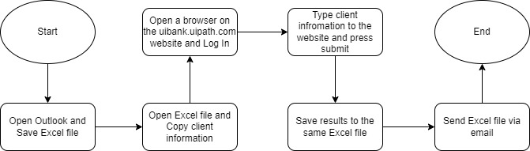

### Low level process map

### [Check AS-IS Low Level Process map](https://ibb.co/4YSL4S1)

## **II.4. Detailed AS IS process steps**

|  |  |  |
| --- | --- | --- |
| Step | Description | Details (Screenshot) |
| 1.1 | **Open Outlook** |  |
| 1.2 | **Find Email and Save Attachments** |  |
| 2.1 | **Open Excel** |  |
| 3.1 | **Open Browser** |  |
| 3.2 | **Type URL address:** [**https://uibank.uipath.com/welcome**](https://uibank.uipath.com/welcome) |  |
| 3.3 | **Log In** |  |
| 3.4 | **Go to Products and select Loans** |  |
| 3.5 | **Apply for a Loan** |  |
| 3.6 | **Copy information from Excel and paste in each field.** |  |
| 3.7 | **If you do not have "Loan Term" or 1,3,5 and 10 by default it will always be 10.** |  |
| 3.8 | **Copy results in the same excel, for each result.** |  |
| 3.9 | **When is complete, Save same Excel, Log Out and Close Bowser** |  |
| 4.1 | **Send report via email** |  |

# 3. TO BE Process Description

This chapter highlights the expected design of the business process after automation.

The process loader is initiated. It opens Outlook, finds all the necessary messages, and saves the attached Excel file. It validates the Excel file and then adds the information from Excel to the queue.

The worker process is initiated. The bot checks the queue's availability. Then it opens a browser on the uibank.uipath.com page, logs in, and navigates to the "apply for a loan" tab. Then, it takes an item from the queue and checks if all the data is filled in. If the result is positive, it fills in the corresponding inputs on the website with the data; if the data is incomplete, it skips the website step and saves the corresponding record to a collection. Then the bot clicks the "Submit" button and saves the results to the collection. After processing all the items from one Excel file, the bot saves the collection to the input Excel file and sends it via Outlook. Then the bot checks for items in the queue from another Excel file, repeating the aforementioned actions if necessary. When the bot finishes its work, it logs out, closes the browser, and Outlook.

**III.1 TO BE Detailed Process Map**

High-level process overview

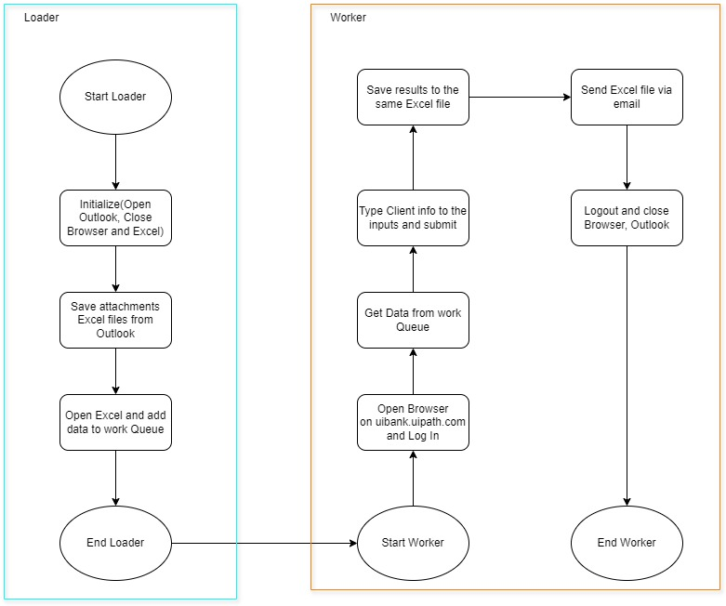

### Low Level process overview

[Check TO-BE process map](https://ibb.co/rv8rJnp)

## **III.2 In Scope for RPA**

The automated process will be developed as described in this document.

* The website from which the information will be extracted is at <https://uibank.uipath.com/loans>
* The extracted data is stored in an Excel file.
* Outlook will be used to extract the Excel file(s) as well as for sending the updated Excel with the new information.
* Customers are over 18 years old and do not request a loan exceeding 100k

## **III.3 Out of Scope for RPA**

The following will be considered out of scope for this automated process:

* Interactions with external systems or applications beyond UiBank, such as third-party job platforms.
* Advanced data analysis or interpretation beyond basic information collection.
* Tasks that require additional human intervention beyond what is described.

## **III.4 Business Exceptions Handling**

### Known Exceptions

The table below reflects all the business process exceptions captured during the process evaluation and documentation. These are known exceptions, met in practice before. For each of these exceptions, define a corresponding expected action that the robot should complete if it encounters the exception.

|  |  |  |  |  |
| --- | --- | --- | --- | --- |
| BE # | Exception name | Step | Parameters | Action to be taken |
| 1.1 | Credentials Issues | Get or Type Credentials | Credentials | Close Browser and Stop the process |
| 2.1 | Missing crucial data in rows prevents the completion of necessary fields on the web. | Open Excel File | Excel Data | Mark row as exception |
| 2.2 | Excel Empty | Open Excel File | Excel Data | Write to Errors Massage File |
| 3.1 | No Email Found | Open Outlook | Email | Write to Errors Massage File |

### Unknown Exceptions

For all the other **unanticipated or unknown business (process) exceptions**, the robot should:

Stop process until issue is resolved

## **III.5 Application Error and Exception Handling**

### Known Errors or Exceptions

The table below reflects all the errors identifiable in the process evaluation and documentation.

For each of these errors or exceptions, define a corresponding expected action that the robot should complete if it is encountered.

|  |  |  |  |  |
| --- | --- | --- | --- | --- |
| # | Error name | Step | Parameters | Action to be taken |
| 1. | Browser Crash | Any step | Error message | Stop process until issue is resolved |
| 2. | The machine is not turned on | First Step | N/A | Wait until the machine on which the bot is running is started and immediately start executing the program |
| 3. | Lack of internet connection | Any step | Error message | Wait until the Internet appears and immediately start executing the program |
| 4. | Excel Crash | Any step | Error message | Stop process until issue is resolved |
| 5. | Excel Path are not available | Get Credentials | Credentials | Stop process until issue is resolved |
| 6. | Outlook Crash | Sending report via Email | Error message | Stop process until issue is resolved |
| 7. | Timeouts | Any Step | Error message | Recover & retry for maximum 3 times |

## **III.6 Reporting**

|  |  |  |  |  |
| --- | --- | --- | --- | --- |
| No. | Report type | Update frequency | Details | Monitoring Tool |
| 1.1 | Exception Report | daily | Summarizes any encountered exceptions during the automation process. | Text Document |
| 1.2 | Excel File | daily | Saved results in excel. | Excel |

# 4.Other

## **IV.1 – Acronyms**

|  |  |
| --- | --- |
| Abbreviation | Long Form |
| URL | Uniform Resource Locator |
| SME | Subject Matter Expert |
| FTE | Full-Time Equivalent |

## **IV.2 – Glossary of RPA Terms**

|  |  |
| --- | --- |
| Term | Description |
| BluePrism | The Robotics Process Automation tool used to automate this process. |
|  |  |

## **IV.3 –** **Additional sources of process documentation**

|  |  |  |
| --- | --- | --- |
| Type | Link or Attachment | Comments |
| N/A | N/A | N/A |